|  |  |  |  |
| --- | --- | --- | --- |
| Angol szóbeli vizsga | Középszint | 1.Vizsgafeladat | Bevezető interjú |

**1. Vizsgafeladat -vizsgáztatói példány**

**Bevezetés (nem értékeljük)**

Mielőtt a tényleges szóbeli vizsga elkezdődik, egy rövid (kb. egyperces) bemelegítő beszélgetés szükséges.

Vizsgáztató:

* Did you sleep well?
* How are you today?
* What did you do yesterday evening?
* When did you get up?
* Is it the first time you are taking an exam?
* How did you come here?
* Are you planning to have a party after the exam?
* ( If “no”: ) What are you going to do after the exam?

Now I am going to ask you a few questions. If you can’t understand me, I can repeat the question once. Let’s get started:

**Tényleges vizsga (ettől a résztől értékeljük):**

Vizsgáztató:

We are going to talk about travelling and tourism.

A What motivates your choice when you decide on a holiday?

**When I decide on a holiday the price of the holiday motivates me the most. I like cheap holidays. It is also important where I go on holiday and who with. I like going on holiday to Lake Balaton with my friends/family.**

BWhat dangers are there when you travel?

**You can be lost when you are on holiday. You can lose your documents, get sunburnt or become ill.**

C Where did you last go on holiday? What means of transport did you take and why? What are the advantages/disadvantages of travelling by car/train/bus/ air?

**I went to Lake Balaton on holiday. I travelled by car. My father drove. The advantages of travelling by car are: it takes you from house to house, it is comfortable.**

**The disadvantage of travelling by car is: petrol is expensive.**

Thank you very much.

That’s the end of your first task.

|  |  |  |  |
| --- | --- | --- | --- |
| Angol szóbeli vizsga | Középszint | 2.Vizsgafeladat | Szituációs feladat |

# 2. Vizsgafeladat - vizsgáztatói példány

A vizsgáztató átadja a vizsgázónak a vizsgázó feladatlapját. A vizsgázó kb. fél percig készülhet.

A vizsgázó példánya

You saw an advertisement on the Internet about summer jobs and you want to apply because you would like to earn money. Look at the pictures and talk about the points with your friend (the examiner).

- types of jobs are available

- why you would like to have a summer job

- advantages/disadvantages of each

- which job you would choose and why

- what you would spend your money on

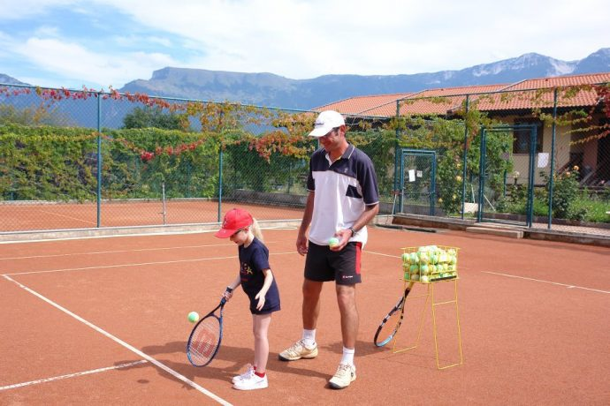 

* What types of jobs can you see in the pictures?  
  - **In the first picture a young man is teaching a child to play tennis. In the second picture a young man is doing the gardening.**
* What are the advantages of being a tennis instructor?
* **The advantages are: it isn’t a hard job, you can work with children.**
* What are the disadvantages?
* **The disadvantages are: you are outside, you can get sunburnt, you don’t have much free time.**
* What are the advantages of being a gardener?
* **The advantages are: you can stay in the fresh air, meet new people.**
* What are the disadvantages of being a gardener?
* **The disadvantages are: you can get tired, got sunburnt.**
* If you earned money in the summer, what would you spend it on?
* **I would go on holiday to Lake Balaton at the end of the summer.**

|  |  |  |  |
| --- | --- | --- | --- |
| Angol szóbeli vizsga | Középszint | 3.Vizsgafeladat | Önálló témakifejtés |

#### **3. Vizsgafeladat - vizsgáztatói példány**

A vizsgáztató átadja a vizsgázónak a vizsgázó feladatlapját. A vizsgázó kb. fél percig készülhet.

# A vizsgázó példánya

These two pictures show different outfits. Compare and contrast the two pictures. Include the following points:

- clothes

- different occasions

- your personal opinion about them

- fashion today

**In the first picture people are wearing a …, a …, …s**

**In the second picture people are wearing a …, a …., …s**

**In the first picture people are hiking in the mountains, they are wearing sporty clothes. In the second picture people are at a ball, they are wearing smart clothes.**

**I like/ I wear…**

**Jeans are always fashionable.**

**…are fashionable colours.**

**….**

**Prompts for the interlocutor:**

* What about clothes for other occasions?
* What’s your favourite outfit for school and for going out?
* What do you think of fashion today and in the future?

**THANK YOU, THIS IS THE END OF YOUR EXAMINATION.**

**3.1 kép**

|  |  |  |  |
| --- | --- | --- | --- |
| Angol szóbeli vizsga | Középszint | 2.Vizsgafeladat | Szituációs feladat |

# 2. Vizsgafeladat - vizsgázói példány

A vizsgázó példánya

You saw an advertisement on the Internet about summer jobs and you want to apply because you would like to earn money. Look at the pictures and talk about the points with your friend (the examiner).

- types of jobs are available

- why you would like to have a summer job

- advantages/disadvantages of each

- which job you would choose and why

- what you would spend your money on

 

|  |  |  |  |
| --- | --- | --- | --- |
| Angol szóbeli vizsga | Középszint | 3.Vizsgafeladat | Önálló témakifejtés |

#### **3. Vizsgafeladat - vizsgázói példány**

# A vizsgázó példánya

These two pictures show different outfits. Compare and contrast the two pictures. Include the following points:

- clothes

- different occasions

- your personal opinion about them

- fashion today

**K 3.1**

